Utkarsh mamodia

19bcs3810

Bd1-b

EXP: **Design a system for LPG gas burners such that, whenever it is turned on, a green LED starts blinking and if it stays on for more than 2000 ms, instead of the green LED, a Red LED starts blinking.**

CIRCUIT DIAGRAM:

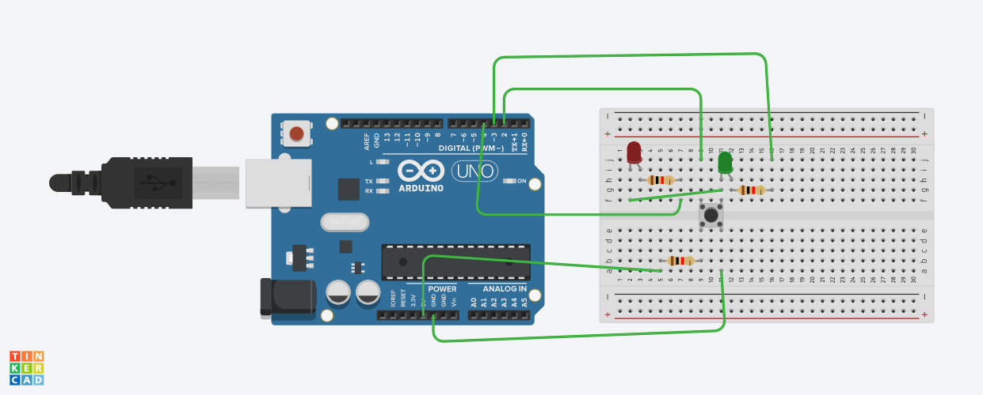

THEORY

CONCEPT USED: Concept of working of Arduino, LED, resistor, switch and breadboard.

LEARNING AND OBSERVATION: We can control the intensity of burner by using two LEDs as indicators.

PROBLEMS: Red led was not turning ON after 2 sec.

TROUBLESHOOTING: Code corrected using delay.

PRECAUIONS: Use resistors in connecting LEDs anode to Arduino’s digital terminals.

LEARNING OUTCOMES: A switch’s state can be know by noticing blinking of particular LED.